

**INMATE EVALUATION AND MANAGEMENT SYSTEM (IEMS)**

**A Project Report**

**Submitted by:**

**KELVIN NG’ANG’A IRUNGU**

**SB30/PU/42106/22**

***in partial fulfillment for the award of the degree***

***of***

**BACHELOR OF SCIENCE**

**IN**

**COMPUTER SCIENCE**

**at**

**PWANI UNIVERSITY**

***MAY, 2024***

# DECLARATION

I hereby declare that the project entitled “Inmate Evaluation and Management System” submitted for the BSc. Computer Science degree is my original work and the project has not formed the basis for the award of any other degree, diploma, fellowship or any other similar titles.

Name: KELVIN NG’ANG’A IRUNGU

Signature: _____________________________________

Date: _________________________________________

# SUPERVISOR DECLARATION

This is to certify that the project titled “Inmate Evaluation and Management System” is the bona fide work carried out by Kelvin Ng’ang’a Irungu, a student of BSc Computer Science of Pwani University, Kenya in partial fulfillment of the requirements for the award of the degree of Bachelor of Science (Computer Science) and that the project has not formed the basis for the award previously of any other degree, diploma, fellowship or any other similar title.

Supervisor name: ______________________________________

Supervisor signature: ___________________________________

Date: ___________________________

# ABSTRACT

The Shimo La Tewa prison currently relies on a paper-based inmate management system, which presents numerous challenges in terms of efficiency, security, and data accessibility. In response, this report outlines the development and implementation of the Inmate Evaluation and Management System (IEMS), a comprehensive and automated solution designed to address these shortcomings. IEMS introduces digital record-keeping capabilities, facilitating swift access, seamless sharing, and secure storage of extensive inmate data. Automation streamlines the inmate evaluation process, with weekly tracking of disciplinary incidents and commendations, culminating in objective ratings that inform release decisions. Robust security measures, including user authentication and access controls, bolster data integrity and thwart unauthorized entry. The adoption of IEMS promises heightened operational efficiency by automating routine tasks, thereby optimizing resource allocation and empowering officers to allocate their time to more impactful endeavors. Leveraging Laravel for the backend, HTML and CSS for the frontend, and MySQL for the database, IEMS offers a user-friendly interface accessible from any location, empowering users to input, retrieve, and assess inmate data in real-time.

Table of Contents

DECLARATION ii

SUPERVISOR DECLARATION iii

ABSTRACT iv

Table of Figures vii

List of Abbreviations viii

CHAPTER 1: INTRODUCTION 1

1.1. 1

1.2. 2

1.3. 2

1.4. 2

1.5. 3

1.6. 3

CHAPTER 2: LITERATURE REVIEW 4

2.1. 4

2.2. 5

2.3. 6

2.4. 8

CHAPTER 3: METHODOLOGY 9

3.1. Introduction 9

3.2. System Development Methodology 9

3.2.1. Suitability of Agile Approach 9

3.2.2. Advantages of Agile Methodology 10

3.2.3. Disadvantages of Agile Methodology 10

3.3. Research Design 11

3.3.1. Qualitative Analysis 11

3.3.2. Data Collection Tools 11

3.4. Sampling Technique 11

3.5. Resources and Budget 11

3.5.1. Software Resources 11

3.5.2. Budget 12

3.6. Gantt Chart 12

CHAPTER 4: SYSTEM DESIGN AND IMPLEMENTATION 13

4.1. 14

4.2. 14

4.2.1. 14

4.2.2. 14

4.3. 15

4.3.1. 15

4.3.2. 16

4.3.3. 18

4.4. 18

4.6. Specifications 20

4.6.1. Input Specifications 20

4.6.3. 22

CHAPTER 5: SUMMARY, CONCLUSION AND RECOMMENDATIONS 21

5.1. 23

5.2. 23

5.3. 23

References 22

# Table of Figures

Figure 1: Gantt Chart 12

Figure 2: Use Case Diagram **Error! Bookmark not defined.**

Figure 3: Level 0 DFD 15

Figure 4: LEVEL 1 DFD **Error! Bookmark not defined.**

Figure 5: Entity Relationship Diagram 17

# List of Abbreviations

IEMS: Inmate Evaluation and Management System

IMS: Inmate Management System

HTML: Hypertext Markup Language

CSS: Cascading Style Sheet

PHP: Hypertext Preprocessor

DFD: Data Flow Diagram

DB: Database

AI: Artificial Intelligence

# CHAPTER 1: INTRODUCTION

## Background

The imperative for enhanced efficiency and effectiveness in inmate evaluation and management systems within prisons has become increasingly apparent in recent years. At Shimo La Tewa prison, antiquated analog record-keeping methods persist, resulting in significant inefficiencies and elevated operational costs. Upon an inmate's admission, personal details and subsequent records are manually transcribed into books, a laborious process that consumes substantial time and resources. Moreover, the subsequent duplication and filing process further exacerbates delays and resource depletion.

Accessing pertinent files and records within the existing system is a cumbersome endeavor, necessitating manual searches through numerous cabinets to locate specific information. This labor-intensive process detracts from more pressing duties, impeding overall operational efficacy. Additionally, the reliance on physical records renders them vulnerable to tampering or unauthorized alterations, posing a threat to the integrity of the legal and corrections framework. Instances of missing records or fraudulent substitutions further underscore the vulnerabilities inherent in this system.

National holidays, such as Jamhuri Day, present an opportunity for the release of prisoners as a means of alleviating prison congestion and rewarding exemplary conduct. However, the absence of clear criteria and susceptibility to corruption in the selection process can compromise the integrity of such initiatives. Consequently, individuals deemed unfit for release may be erroneously granted freedom, thereby undermining public safety and eroding confidence in the rehabilitation process.

The Inmate Evaluation and Management System (IEMS) represents a concerted effort to address these systemic shortcomings. Leveraging contemporary computer technology, IEMS operates as a merit-based web application accessible via the internet. Incorporating robust user verification and authentication protocols, the system enables the assignment and storage of merit and demerit points within a modernized database infrastructure. By automating the evaluation process and generating comprehensive reports, IEMS facilitates informed decision-making regarding inmate eligibility for early release, thereby promoting transparency and accountability within the corrections system.

## Problem Statement

Shimo La Tewa prison’s existing inmate evaluation and management was constrained by the use of outdated analog record-keeping methods. In addition, there were several issues associated with the manual recording of inmate information including time consuming workflows, higher costs and increased errors. Fast retrieval was also hindered by their dependence on hard-copy documents that are kept in cabinets. Besides, they suffered from risks associated with manual handling of records that can create room for alterations, hence compromising the legal and corrections system integrity.

There was no systematic method of capturing and measuring indiscipline among inmates, which made it difficult for prisons to identify the patterns of the behavior of each prisoner and conduct a fair assessment.

These challenges were be addressed through The Inmate Evaluation and Management System that I am proposing. This software is based on technology which makes it easy to record data and access it securely. It also comes with a standard method of scoring of inmates depending on their behavior. The program has provided a more improved, transparent, and reliable evaluating tools for inmates’ treatment and rehabilitation process as well as a better system of prison managing.

## Objectives

The objectives of the inmate evaluation and management system were:

1. To gather information about the existing prison management system and the criteria used in evaluating those who qualify for early release.
2. To analyze the functions that the system will perform in order to effectively design it. Such functions include storage of inmate data and rating them as per who qualifies for early release.
3. To create a simple design, which will highlight some core functions like input, search, and update using the dummy dataset.
4. To implement the Inmate Evaluation and Management System web application.

## Research Questions

Here are the research questions that were used to guide the development of this system:

1. What were the suitable methods to be used to collect and gather information about the existing systems?
2. What would be the functions performed by the proposed system?
3. What were the best tools and approach to be used in actualizing the system?
4. What technology was the most suitable in implementing the system?

## Project Scope

The scope of this project was limited to the inmate’s registration details, discipline ratings and suggesting those qualified for early release. Due to the constraints of time and budget, it did not focus on other areas of a Prison.

## Significance

The Inmate Evaluation and Management System:

1. Reduced running costs.
2. Kept of digital records that are tidier and require less physical space.
3. Processed data faster.
4. Increased confidence of the inmates.
5. Led to reduced overcrowding in prisons.
6. Increased self-health of the inmates and staff.
7. Provided further data security.

# CHAPTER 2: LITERATURE REVIEW

## Introduction

As an essential instrument for contemporary prison administration, inmate management systems (IMS) are vital to the efficient and successful assessment, supervision, and rehabilitation of prisoners. A growing need for data-driven decision making, improved security, and accessibility, along with the complexity of jail operations, have propelled the evolution of IMS from manual record-keeping methods to complex digital systems.

Traditional IMS, characterized by paper-based records, suffered from several limitations, including inefficiency, limited accessibility, susceptibility to alterations and damage, lack of standardization, and outdated technologies (Garland, 2001; Pratt, 2008). These challenges hindered effective inmate management, making it difficult to track records, assess risk factors, and make informed decisions.

In response to these shortcomings, digital IMS have emerged as a transformative force in correctional settings. These systems offer a range of advantages over traditional methods, including:

1. Enhanced Data Security and Integrity:

Digital IMS employ robust encryption mechanisms, access controls, and audit trails to safeguard inmate information from unauthorized access and manipulation (Pratt, 2008). This ensures the confidentiality and integrity of sensitive data, protecting both inmates and correctional staff

1. Improved Efficiency and Time Management:

Digital record-keeping streamlines data entry, retrieval, and analysis, significantly reducing the time and resources required for inmate management tasks (Garland, 2001). This allows correctional personnel to focus on more value-added activities, such as inmate interaction, rehabilitation programs, and risk assessment.

1. Enhanced Accessibility and Collaboration:

Using digital system, the authorized personnel can have a remote access to prisoners’ records from any part of the world where there is internet connection (Pratt, 2008). This encourages cooperation among different departments and agencies thus enhancing swift decision-making and appropriate prevention strategies.

1. Data Standardization and Sharing:

Digital IMS adhere to standardized data formats and protocols, enabling seamless data sharing and integration with other systems (Garland, 2001). This promotes consistency and accuracy across different departments and institutions, enhancing data-driven decision-making.

1. Advanced Analytics and Risk Assessment:

Digital systems leverage sophisticated data analytics tools to identify patterns, trends, and risk factors associated with inmate behavior (Pratt, 2008). This enables correctional staff to make evidence-based decisions, prioritize interventions, and allocate resources effectively.

Digital IMS is one the most important factors which are changing how correctional facilities manage and engage with inmates nowadays. These processes act as very important aids towards making efficiency, ensuring security and providing data-based decision to ensure smooth rehabilitation process. With time, IMS would need to grow with current technologies such as electronic communication systems that work together with other aspects of prisons operations.

## Merits of Automation

The use of digital inmate management systems (IMS) has revolutionized prison operations, yielding numerous advantages in terms of effectiveness, safety, data-driven decision-making, and rehabilitation initiatives. These systems are now essential tools for managing prison populations in the modern era, helping to ensure public safety, encourage rehabilitation, and effectively manage the inmate population.

1. Increased productivity and efficiency

IMS streamlines prisoner record-keeping by automating data entry, retrieval, and analysis, doing away with the need for laborious manual procedures. This frees up time for correctional staff to work directly with prisoners, supporting their rehabilitation plans, and attending to their specific needs (Garland, 2001; Pratt, 2008).

1. Data integrity and security

IMS guard sensitive inmate data against unauthorized access, manipulation, or breaches by utilizing strong security measures like encryption and access controls (Pratt, 2008). This preserves the confidentiality of prisoners and the integrity of the criminal justice system.

1. Improved accessibility and collaboration

According to Pratt (2008), authorized personnel possess the ability to access inmate information from any location with an internet connection, which facilitates prompt decision-making and informed interventions. Additionally, by enabling collaboration between various departments and organizations, this remote access supports coordinated case management and risk assessment.

1. Enabled data sharing and standardization.

IMS enable smooth data exchange with other systems, including databases used by law enforcement agencies and courts, by conforming to standard data formats and protocols (Garland, 2001). Because of this integration, correctional staff can view an inmate's history, behavior patterns, and rehabilitation status holistically, empowering them to customize interventions to meet the needs of each individual and make well-informed decisions.

1. Inclusion of sophisticated analytics tools

These tools are used to glean valuable insights from enormous volumes of prisoner data (Pratt, 2008). Through the use of these tools, correctional staff can make well-informed decisions regarding classification, security, and rehabilitation programs by recognizing patterns, trends, and risk factors linked to the behavior of inmates. This data-driven strategy enhances public safety by lowering the chance of recidivism.

All things considered, digital IMS provide a number of advantages that strengthen prisoner management, increase effectiveness, foster teamwork, and enable data-driven decision-making. IMS are anticipated to advance in sophistication and integration into prison operations as technology does, becoming a crucial component of inmate management and rehabilitation programs.

## Demerits of the Existing System

Digital inmate management systems (IMS) have many advantages, but there are also some possible disadvantages and moral dilemmas that need to be carefully evaluated. These worries cover everything from privacy and data security problems to moral conundrums and the possibility of making already-existing disparities in the criminal justice system worse.

1. Security flaws and data breaches. This is one of the main issues with digital IMS. Because computerized systems store and analyze sensitive inmate data centrally, hackers and other bad actors find them appealing targets (Pratt, 2008). Inmates may suffer serious consequences from identity theft, financial fraud, or blackmail as a result of data breaches.
2. Another source of ethical quandaries is the massive gathering and examination of prisoner data. Decisions regarding parole, placement, and access to rehabilitation programs could all be influenced by this data, which could be used to discriminate against prisoners (Garland, 2001). These actions could exacerbate preexisting prejudices and impede the process of recovery.
3. Digital IMS might make current disparities in the criminal justice system worse. Limited access to technology or education among prisoners may make it difficult for them to use digital platforms, which could make it more difficult for them to participate in rehabilitation programs or get access to crucial information (Pratt, 2008). This access restriction may exacerbate the marginalization of underprivileged populations and prolong cycles of inequality.
4. The absence of accountability and transparency in digital IMS. It may be challenging to recognize and correct possible biases or mistakes in data analysis due to the complexity of these systems and their reliance on proprietary software (Garland, 2001). The public's confidence in correctional facilities may be damaged by this lack of transparency, which may also make it more difficult to hold software developers and vendors responsible for data misuse or discriminatory practices.
5. Discriminatory uses of digital IMS may occur. For instance, information about a prisoner's political connections, religious convictions, or social media usage may be utilized to identify them for monitoring, reprimand, or even harsher actions (Pratt, 2008). This data misuse may result in discrimination, denial of necessary services, or even targeted harassment.
6. It can be difficult and resource-intensive to integrate and install digital IMS. Significant investments in infrastructure, training, and technology are needed to adopt and adjust to these systems (Garland, 2001). Correctional facilities could find it difficult to set aside the funds required for a successful deployment, which could cause delays, inefficiencies, and employee annoyance.

In conclusion, even if digital IMS have a lot to offer in terms of effectiveness, security, and data-driven decision-making, it is critical to recognize and deal with any potential negative effects as well as ethical issues related to these technologies. Correctional facilities need to embrace appropriate data practices, guarantee accountability and openness, and proactively manage the danger of bias and misuse. Correctional systems may maximize the benefits of IMS while lowering dangers and advancing just and equitable treatment of prisoners by carefully weighing these factors.

## Conclusion

Prison operations have been completely transformed by digital inmate management systems (IMS), which provide numerous advantages in terms of effectiveness, safety, data-driven decision-making, and rehabilitation initiatives. These systems do, however, have some possible disadvantages and ethical issues that need to be properly considered. Correctional facilities can optimize the advantages of IMS while advancing just and equitable treatment of convicts by recognizing and reducing these dangers.

# CHAPTER 3: METHODOLOGY

## 3.1. Introduction

This chapter focused on the methodology employed in the development of the Inmate Evaluation and Management System. The project adopted a systemic methodology that aimed at eliminating the shortcomings that are intrinsic to the analog recording system.

System Development Methodology

Agile method was the proposed approach as it provided a structure that fitted the changing needs of the Automated Inmate Evaluation and Management system. This project benefitted with agile approach due to its iterative nature that involves adjustment and improvement as users engage and project evolves.

Research Design

Each sub-chapter took a more exploratory and detailed approach to the methodological decisions employed during the initial stage of system improvement. It identified in details of specific data collection tools utilized thus revealed how information could be acquired from different points.

Data Collection tools and resource allocation.

The section also specified the types of hardware, software and manpower needed. Developing a prototype. The last part focused on the budget for the proposed system and a Gantt chart

## 3.2. System Development Methodology

The Agile methodology was selected for the development of the Inmate Evaluation and Management System (IEMS) due to its iterative and flexible nature. Agile methodology is well-suited for projects with evolving requirements and a need for continuous feedback from stakeholders.

Agile methodology is an iterative and incremental approach to software development that focuses on delivering value to customers early and often. It emphasizes adaptability, flexibility, and continuous improvement, allowing teams to respond quickly to changing requirements and user feedback. Agile is particularly well-suited for projects with complex or evolving requirements, where traditional waterfall methodologies may struggle to keep up.

### 3.2.1. Suitability of Agile Approach

1. Iterative and Flexible Nature.

Agile methodology is characterized by its iterative and flexible nature, which aligns perfectly with the dynamic and evolving requirements of the IEMS. As the system deals with inmate evaluation and management, it was crucial to adapt to changing regulations, institutional needs, and feedback from prison officials, inmates, and rehabilitation experts. This approach allowed for continuous refinement and improvement based on feedback, ensuring the IEMS remained relevant and effective.

1. User-Centric Approach.

Agile methodology emphasizes user involvement throughout the development process, which was particularly important for the IEMS. By actively engaging with stakeholders, including prison officials, inmates, and rehabilitation experts, the IEMS team gathered valuable insights into their needs, preferences, and concerns. This user-centric approach ensured that the IEMS was designed to meet the specific requirements of the prison environment and address the challenges faced by all stakeholders.

1. Early and Continuous Feedback.

Agile methodology promoted early and continuous feedback, which was essential for developing a robust and user-friendly IEMS. By incorporating feedback from stakeholders at each stage of development, the IEMS team identified and addressed potential issues early on, preventing costly rework and ensuring the system aligned with user expectations.

1. Adaptability to Changing Requirements.

The prison environment is constantly evolving, with new regulations, policies, and inmate needs emerging regularly. Agile methodology's adaptability is crucial for the IEMS to keep pace with these changes. The iterative nature of Agile allows the IEMS to be modified and updated as needed, ensuring it remains relevant and effective over time.

1. Collaboration and Teamwork.

Agile methodology fosters collaboration and teamwork among developers, prison officials, inmates, and rehabilitation experts. This collaborative approach promoted a shared understanding of the project goals and encouraged diverse perspectives to be considered. By working together, the IEMS team developed a system that is not only technically sound but also meets the practical needs of the prison environment.

### 3.2.2. Advantages of Agile Methodology

1. In Agile methodology the delivery of software is continuous.
2. The customers are satisfied because after every short period, a working feature of the software is delivered to them.
3. If the customers have any feedback or any change in the feature then it can be accommodated in the current release of the product.
4. In this methodology attention is paid to the good design of the product.
5. Changes in the requirements are accepted even in the later stages of the development.
6. An Agile/Scrum approach can improve organizational synergy by breaking down organizational barriers and developing a spirit of trust and partnership around organizational goals.

### 3.2.3. Disadvantages of Agile Methodology

1. In Agile methodology the documentation is less.
2. Sometimes in Agile methodology the requirement is not very clear hence it’s difficult to predict the expected result.
3. In few of the projects at the starting of the software development life cycle it’s difficult to estimate the actual effort required.
4. Because of the ever-evolving features, there is always a risk of the ever-lasting project.
5. For complex projects, the resource requirement and effort are difficult to estimate.

## 3.3. Research Design

### 3.3.1. Qualitative Analysis

Qualitative analysis was suitable for the development of the Inmate Evaluation and Management System as the methods relate to the human aspects in a complex prison setting. This was achieved using methods such as interviews and questionnaires to capture subjective experience, organizational politics, and possible difficulties.

### 3.3.2. Data Collection Tools

* Semi-structured interviews with prison officials, inmates, and rehabilitation experts were used to gain insights into the previous evaluation and management practices, challenges faced, and desired system functionalities.
* Review of existing inmate records to understand the current data structure and identify areas for improvement.
* Observation of daily prison operations to gain contextual understanding of the challenges and opportunities for system integration.

## 3.4. Sampling Technique

1. Purposive Sampling

This method involves selecting participants based on specific criteria relevant. For this project, purposive sampling was used to ensure representation from key stakeholders, such as prison staff, administrators, and diverse groups of inmates.

1. Stratified Sampling

Stratified sampling involves dividing the population into subgroups (strata) based on certain characteristics, and then randomly selecting samples from each subgroup. This was useful in ensuring a balanced representation of different roles and demographics within the prison population.

By combining purposive sampling to ensure representation of key stakeholders and stratified sampling to account for the diversity within the prison population, it enabled obtaining a more comprehensive understanding of the perspectives and experiences related to the Inmate Evaluation and Management System.

## 3.5. Resources and Budget

### 3.5.1. Software Resources

* Programming language: PHP
* Web framework: Laravel
* Databases: MySQL
* GitHub
* XAMMP Web Server
* Visual Studio Code
* Node JS

### 3.5.2. Budget

|  |  |  |  |
| --- | --- | --- | --- |
| ITEMS | BUDGET | DURATION | TOTAL |
| Laptop | 30,000 | 4 months | 30,000 |
| Wi-Fi | 2,500 (monthly) | 4 months | 10,000 |
| Printing | 500 | 4 months | 500 |
| Airtime | 1,500 (monthly) | 4 months | 6,000 |
| TOTAL |  |  | 46,500 |

### 3.6. Gantt Chart

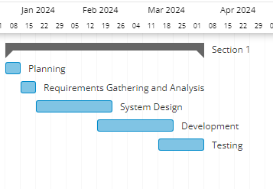

*Figure 1: Gantt Chart*

# CHAPTER 4: SYSTEM DESIGN AND IMPLEMENTATION

## Introduction

This chapter goes into depth on the actual design of the Inmate Evaluation and Management System. Areas covered include Requirements definition, design approach used, system testing, screenshots of the system functionality areas and a deep understanding of the developed system.

## Requirements:

### Functional Requirements

* **User Registration, verification and authorization.**

Users should be able to create their accounts. The email should be verifiable and whenever they log back in, 2 factor authentication can be implemented for further security.

* **Prison Profile Management.**

The prison admin should be able the change the logon password, change certain account details, enable and disable 2FA and also delete the account.

* **Produce relevant reports.**

The system should be able to produce necessary reports required in managing the system records and those producing the suggested names of the prisoners who qualify for early release.

### Non-functional requirements.

* **Performance.**

The system should be responsive and run smoothly with the available or suggested computer system to be used.

* **Security.**

The system should only allow authorized users to access their data.

* **Scalability.**

The system should be able to accommodate future improvements that may be required.

* **Reliability.**

The system should be available whenever needed and be able to handle few downtimes.

## System Design

### Use Case Diagram

**IEMS**

*Figure SEQ Figure \* ARABIC 2: Use Case Diagram*



USER



ADMIN

### Data Flow Diagrams (DFD)

**Level 0 DFD:**

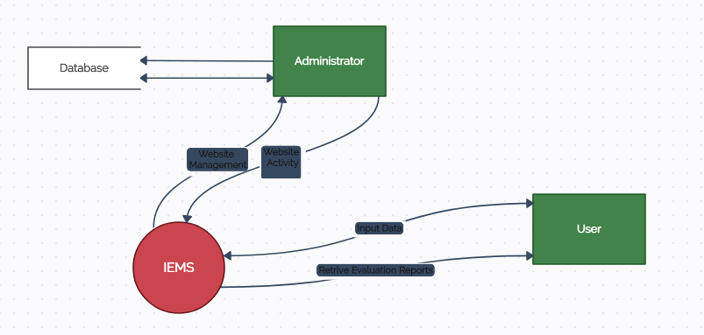

*Figure 3: Level 0 DFD*

**Level 1 DFD:**

Database

*Figure SEQ Figure \* ARABIC 4: LEVEL 1 DFD*

REGISTER CRIMES

VIEW RANKING REPORTS

USER REGISTRATION

ADMIN

USER

MANAGES USERS AND DATABASE

LOGIN

LOGIN

ADD MERITS/ DEMERITS

IEMS

### Entity Relationship Diagram

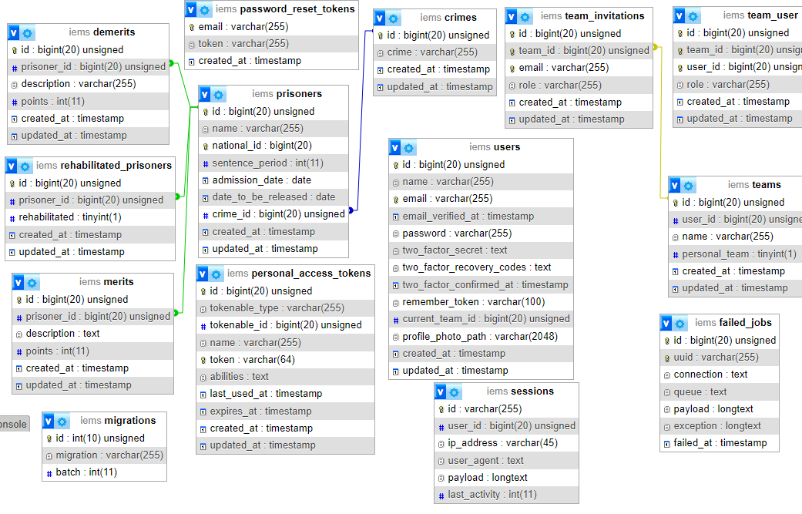

*Figure 5: Entity Relationship Diagram*

## System Testing

The system underwent thorough testing to ensure its reliability and user-friendliness. The following tests were conducted:

1. Unit Testing: Individual components and functions were tested to verify they operated correctly.
2. Integration Testing: Modules were integrated and tested to ensure proper communication and data flow.
3. User Acceptance Testing: Potential users evaluated the system to validate its usability and adherence to requirements.
4. Performance Testing: The system's performance was assessed under various loads and conditions. It performed as expected.
5. Security Testing: Vulnerabilities and potential security risks were assessed, identified and addressed.

Overall, the testing process revealed satisfactory results, with minor issues addressed and resolved during the development cycle.

* 1. **Screenshots**

**Dashboard**

This is the main landing page after the user logs in.

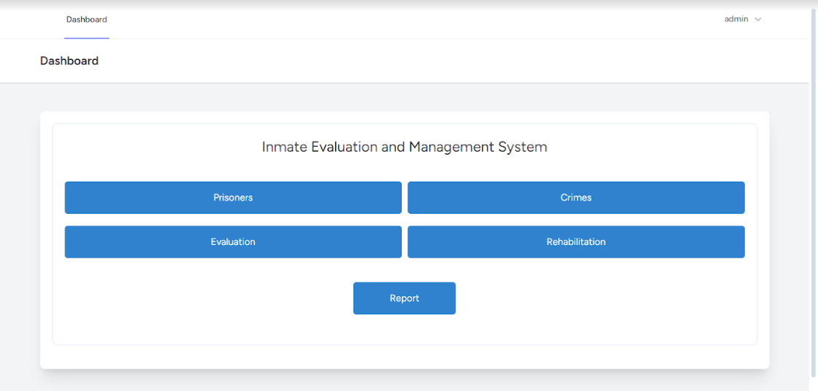

**Prisoners**

This page enables the user to add new Prisoner Records, View and edit existing records.

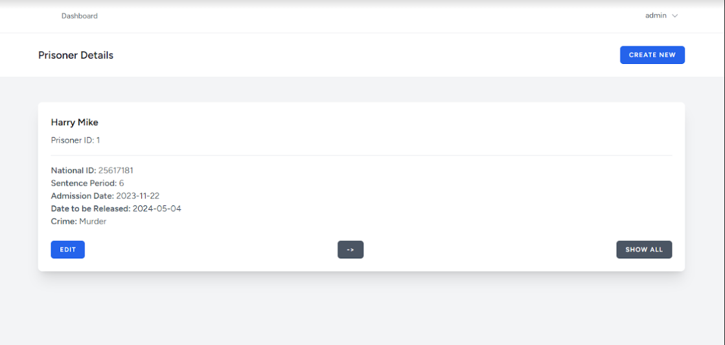

**Crimes**

This page enables the user to add and manage the crimes records.

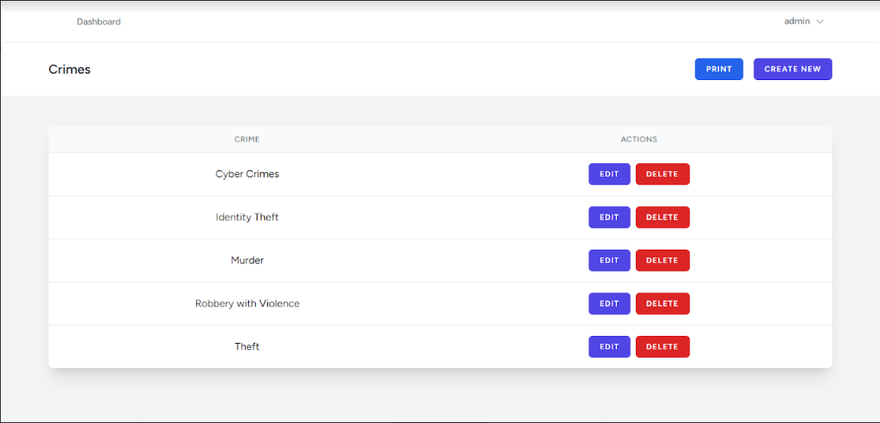

**Evaluation:**

This page contains the forms to add merits and demerits, together with the views for the merits and demerits records.

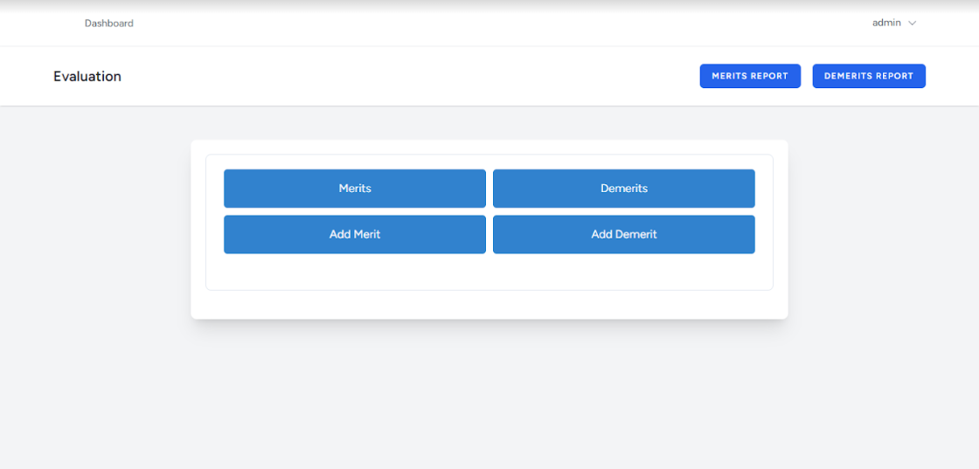

**Rehabilitation:**

This page if for special prisoners, who have served 80% of their sentences, have at least 1 merit and 0 demerits. Being in this page automatically adds the prisoner extra points.

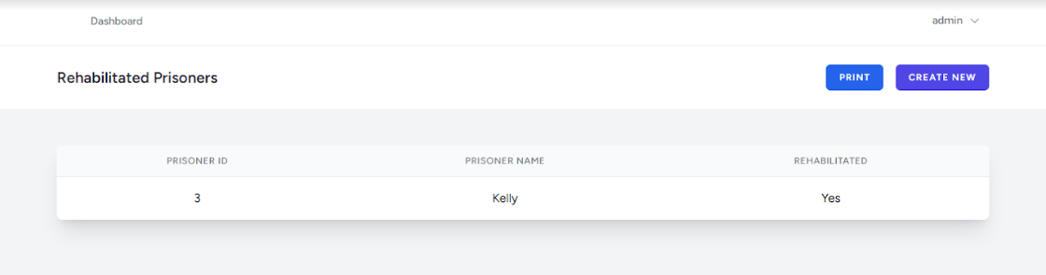

**Ranking Report:**

This is the final report compiling the points and giving the suggestions for who qualifies for early release.

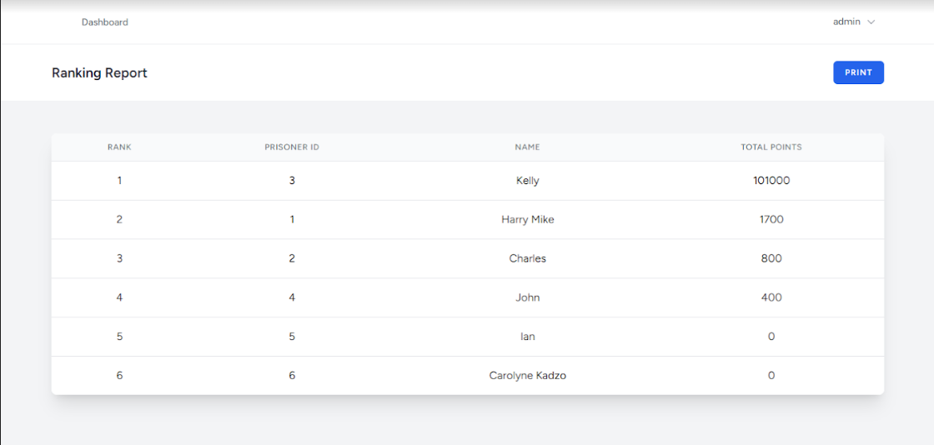

## 4.6. Specifications

### 4.6.1. Input Specifications

The system accepted various forms of input, including:

1. User registration data: name, email, password.
2. Prisoner Details: name, national ID, sentence period, admission date, date to be released, crime.
3. Crime details.
4. Merits and Demerits forms: prisoner ID, points.
5. Rehabilitated form details: prisoner ID.

Input validation mechanisms were implemented to ensure data integrity and security, such as password strength and input types.

**4.6.2 Output Specifications**

The system generated the following outputs:

* Rendered web pages with dynamic content.
* Prisoner records.
* Merits and Demerits reports.
* Final ranking report.

The outputs designed contained all the relevant information that aligned with the objectives of the project.

### Justification of the Programming Language Used

PHP is a commonly used language that I am personally familiar with. It comes with lots of extensions and a large community that enable one to create websites faster and get support for almost any issue experienced.

It is also compatible with a lot of technologies and other languages. The Laravel Framework provides a platform ready with JavaScript support, integrates very well with HTML and CSS.

# CHAPTER 5: SUMMARY, CONCLUSION AND RECOMMENDATIONS

## Summary

The Inmate Evaluation and Management System has been designed to improve the current Inmate evaluation system in place. It ensures user verification during registration through sending a confirmation email which completes the registration process. User authentication during login has been implemented by use of Two-Factor Authentication applications. Data is stored in a modern database system which further reduces clutter, occupation of large physical spaces, it enabled electronic backup methods and overall access control.

## Conclusion

The Inmate Evaluation and Management System was a successful project. It has lightened the load of the current prison administrators in coming up with a list of the qualified prisoners for early release. It saves on costs as it reduces a lot of paperwork, security personnel to be employed to protect records, the panel to select the prisoners has also been cut down as most of the work is done by the system and also increased the speed of the process by making use of modern computing power. Further improvements may be done as policies change and new methods are employed. The system is modular enough to support incremental improvement.

### Recommendations

Based on the experiences and insights gained during the project, the following recommendations are proposed:

1. Continuous enhancement: Regularly gather user feedback and incorporate new features and improvements to keep the application relevant to the country’s continuously changing policies.
2. Expanded usability: Explore opportunities to extend the application’s usefulness beyond prison systems. The algorithm may be altered to suit other areas that require behavioral evaluation and personal improvement.
3. Mobile application Development: A mobile application version may be created and the user levels of access may be increased. Instead of individual prisons viewing the data, various relevant government sectors may view. An overall report may be generated from the systems within all the prisons countrywide.
4. Exploration of emerging technologies: Technology is ever evolving. For example, AI has brought about a lot of functionality in the industry. By use of Machine learning and other new technologies, better evaluation methods may be integrated into the system.

# References

Alper, S., & Smith, A. (2012). The impact of technology on correctional management. Journal of Correctional Education, 63(2), 156-173.

Beck, A. J. (2017). Data sharing and integration in correctional information systems. Journal of Criminal Justice Information and Statistics, 17(3), 1-12.

Carlson, J. (2013). The benefits of digital inmate management systems. Correctional Facility Planning and Management Association, 1-10.

Cole, A., Smith, L., & Galler, D. (2015). Digital inmate management systems and data security. RAND Corporation, 1-30.

Garland, J. A. (2001). Mass incarceration: Race and the American criminal justice system. Belknap Press of Harvard University Press.

Pratt, J. (2008). Inmate management systems: A review of the literature. Journal of Correctional Education, 59(3), 243-257.